**Count** **Herman Van Rompuy**

**Former President of the European Council**

Elected as the first full-time President of the European Council in November 2009, Herman Van Rompuy took office when the Lisbon Treaty came into force on 1 December 2009. In 2012, he was re-elected for a second (and last) term starting on 1 June 2012 and running until 30 November 2014.

At the time of his first election, Herman Van Rompuy was Prime Minister of Belgium. Prior to that he had served in Belgium as Speaker of the House of Representatives (2007-2008) and in several government positions, including as Secretary of State for Finance and Small Businesses (1988) and Vice-Prime Minister and Minister of Budget (1993-1999). His is Minister of State (since 2004).

A former economist at the National Bank of Belgium, Herman Van Rompuy began his political career in 1973 as national vice-president of his party’s youth movement. He was president of the Flemish Christian Democrats (1988-1993). He served in the Belgian Parliament, in turn as Senator (1988-1995) and Member of the House of Representatives (1995-2009).

Herman Van Rompuy holds a Bachelor in Philosophy, and a Master in Economics from the university K.U. Leuven.

He was born in Etterbeek (Brussels), on 31 October 1947, and is married with Geertrui Windels; they have four children and nine grandchildren.

He was professor at the KU Leuven. He teached at the UC Louvain, SciencePo in Paris and the College of Europe (Bruges and Natolin).

He was the President of the European Policy Centre (2015-2022).

He is president of the Administrative Council of the College of Europe.

King Philip granted him the noble title of count in 2015.

**Education:**

Greek-Latin humanities, Sint-Jan Berchmanscollege Brussels (1965)

Bachelor of Philosophy, K.U.Leuven (1968)

Master in Economics, K.U.Leuven (1971)

**Career history:**

Attaché research center, National Bank of Belgium (1972-1975)

Adviser Cabinet Prime Minister L. Tindemans (1975-1978)

Adviser Cabinet Minister of Finance G. Geens (1978-1980)

Director Centrum voor Politieke, Economische en Sociale Studies (research center of the Christian Democrats) (1980-1988)

Professor Handelshogeschool Antwerpen (1980-1987)

Professor Vlaamse Economische Hogeschool Brussel (VLEKHO) (1982-2008)

Professor at the College of Europe (Bruges and Natolin), KUL (Leuven)

President of the European Policy Center, Brussels (2015-2022)

President of the Administrative Board of the College of Europe, Bruges (2019)

**Political career**:

National vice-president C.V.P.-Jongeren (1973-1977)

Member of the National C.V.P. Buro (1978-2009)

C.V.P.-negotiator for the government formation Martens-III, IV, V, VI, VII, VIII and Dehaene I, II (1980-1995)

Senator (1988-1995)

Secretary of State of Finance and Small Businesses (May 1988-Sept. 1988)

C.V.P.-party National President (Sept. 1988-Sept. 1993)

Vice-Prime Minister and Minister of Budget (Sept. 1993-July 1999)

MP in the House of Representatives (1995 -2009)

Minister of State (since Jan. 2004)

Speaker of the House of Representatives (July 2007- Dec. 2008)

Royal Explorer (Sep. 2007)

Royal Conciliator (Oct. 2007)

Prime Minister (Dec. 2008 - Nov. 2009)

President of the European Council (Dec. 2009 - 2014)

Books

"*De kentering der tijden*", book published by Lannoo, 112 p. (1979)

"*Hopen na 1984*", book published by Davidsfonds, Horizonreeks (September 1984)

"*Het christendom. Een moderne gedachte*", book published by Davidsfonds, Forumreeks (September 1990)

"*Vernieuwing in hoofd en hart. Een tegendraadse visie*", book published by Davidsfonds, Forumreeks (Autumn 1998)

"*De binnenkant op een kier. Avonden zonder politiek*", book published by Lannoo, 165 p. (2000)

"*Dagboek van een vijftiger*", book published by Davidsfonds, 144 p. (October 2004)

"*Haiku*", Poezie Centrum, Gent, 125 p. (April 2010) (translated in five languages)

"*In de wereld van Herman Van Rompuy*", with Kathleen Cools, Borgerhoff&Lamberigts, 200 p. (October 2010)

*"Haiku 2"*, Poëzie centrum, Gand, 93 p. (October 2013) ( translated in four languages)

"*Europe in the storm"*, Davidsfonds, 2014, (translated in English, French, Greek, Portuguese)

“*Anti-memoires”*, Amsterdam University Press, 2018, (translated in French)

“*Mijmeringen*”, Dagboeknotities en haiku’s, Standaard Uitgeverij, Davidsfonds, 2021

*“Wat wij waren”*, gesprek met Rik Van Cauwelaert, Standaard uitgeverij, Davidsfonds, 2022

**Awards**

Nobel Prize of Peace 2012, Reception on behalf of the EU

Charlemagne Prize (Internationale Karlspreis), Aachen (29 May 2014)

Benelux-Europa Prize, Breda (12 June 2010)

Médaille d'Or de la Fondation Jean Monnet, Lausanne (18 October 2014)

Michele de Gianni Award, Brussels (4 October 2013)

ESMT Responsible Leadership Award, awarded by the European School of Management and Technology, Berlin, (3 July 2014)

Golden Business Centre Club Statuette Award, awarded at the Grand Gala of Polish Business Leaders, Warsaw (25 January 2014)

European Prize Coudenhove-Kalergi 2012, Vienna (16 November 2012)

Otto von der Gablentz Prize, The Hague (18 April 2012)

Honorary senator E Meritu et Honoris Causa of the Movement for a United States of Europe – Action Centre for European federalism (AEF - BVSE) , Antwerp (5 February 2012)

"Gouden Penning" awarded by the Royal Flemish Academy of Belgium for Science and the Arts, Brussels, (14 January 2012)

Nueva Economía Forum Prize, Madrid (10 December 2010)

"Collier du Mérite européen" awarded by the European Merit Foundation, Luxembourg (25 November 2010)

Harvard Club of Belgium Leadership Prize, Brussels (8 September 2010)

Willem van Oranje-Penning, Leiden (October 2014)

Aureus Vives award, Kortrijk 2015

Leopold Kunschak Preis, Vienna 2015

Haiku Ambassador for the EU-Japan Friendship (2015-2023i)

Merit Award, Eurpean People's Party, October 2015

Flames of Peace Award, Brussels (February 2016)

Comenius Prize, Nerherlands (April 2016)

Annual Prize for Pro-European Policy TV Evropa, Bulgaria (April 2016)

Culture Prize, Asia Cosmopolitan Awards (15 January 2017)

**Honorary Doctorate**

Université Catholique de Louvain (2 February 2010)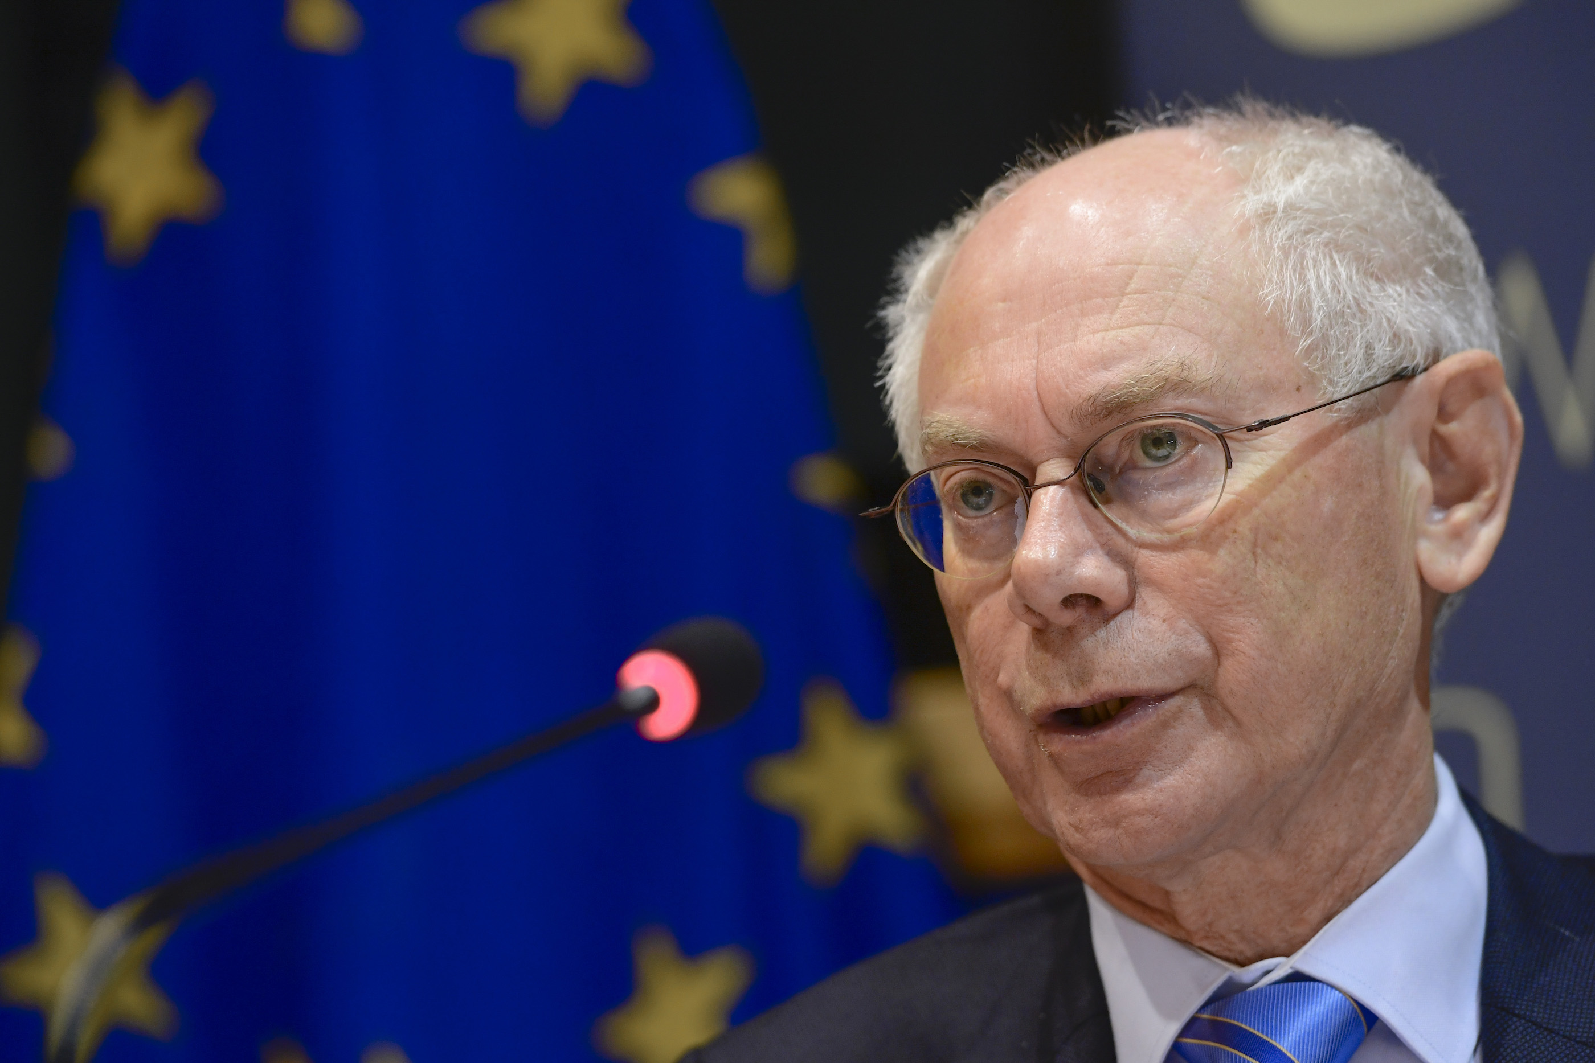

Kobe University Brussels European Centre (4 March 2011)

University of Ghent (18 March 2011)

Katholieke Universiteit Leuven (1 June 2012)

University of Foreign Languages of Baku (5 July 2012)

Hanoi National University (1 November 2012)

Universidad C.E.U. San Pablo in Madrid (13 December 2013)

University of Abomey-Calavi, Benin (21 February 2014)

Vrije Universiteit Amsterdam. (20 oktober 2015)

Kansaï University, Osaka, Japan (4 november 2015)

University of St. Andrews, Scotland ( June 2016)

University of Kent (July 2016)

Regent's University London (Februari 2017)

Carleton University, Ottawa, Canada (November 2017)

University of Lodz , Poland, (June 2020)

National University of Kyiv, Ukraine (June 2022)

Trinity College, Dublin, Ireland (June 2024)

**Distinctions**

Grand Ribbon holder of the Order of Leopold, Belgium (2009))

Grand Officer in the Order of the Legion of Honour, France (December 2011)

Honorary Citizenship, Beersel, De Haan, Olen, Kortessem and Sint-Genesius-Rode (Belgium) and Matsuyama (haiku-capital, Japan)

Grand Officier de l'Ordre National de Cote d'Ivoire (7 August 2012)

National order "Star of Romania" in the rank ofthe Grand Cross, Bucharest (25 April2013)

Ordre National du Benin, Cotonou (20 February 2014)

Order of the White Double Cross of Second Class, Bratislava (30 April 2014)

Knight Grand Cross in de ­Order of Oranje Nassau’, Netherlands, Oktober 2014

On 21 July 2015 His Majesty King Philip of Belgium announced to ennoble Mr Van Rompuy and grant him the title of Count.

Order for Exceptional Merits of Slovenia, october 2015

Grand Cordon of the order of the Rising Sun, Japan,

november 2015

Grand Cross of the Order of Malta, 29 June 2016